العربية
Name: Aqeela N. Abed.
Place of birth: Baghdad – AL Mansour
Marital status: Married
Nationality: Iraqi
Address: Hi- Aljame'a - 627 m - 10 g - d 19
City and State: Baghdad - Al karkh
Lecture : Al-Iraqia University – College of Medisine\Computer &Int. Department

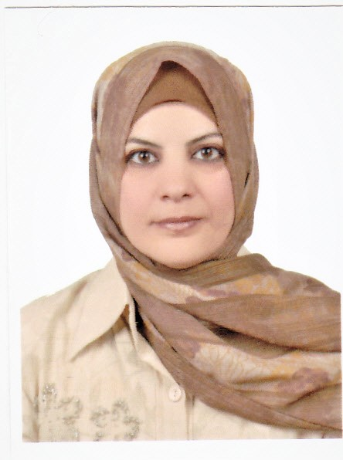
AL-Iraq \ Baghdad
+96407700765066
aqeela.n.abed@aliraqia.edu.iq

ass.lec.aqeela@gmail.com
Married
Administrative Work :

- Lecture (Computer Science for the first Year) /
  - Collège of Médicine / Iraqi University of
  - 9 \ 11 \ 2015 and continuing until now.
- Chief Engineer / Department of Medicine City /
Ministry of Health for the period from 17 \ 11 \ 1997 to 8 \ 11 \ 2015

Experience related to the job :
- Installation and maintenance, and repair of computer equipment
(software & hardware).
- Maintenance and repair of medical devices (software & hardware).
languages
- Researcher in Artificial Intelligence and Medical Imaging,
Arabic
English
with a focus on Ultrasound-based Liver Disease Diagnosis.
Education or qualifications:
- Bachelor of Electronic and Communications Engineering from the University of Technology
- Master of Satellite Communication Engineering from the University of Technology

Interests
Reading
Sports
Travel
Internet

Experience and personal skills
- Computer (Windows)
- Internet & Email
- Microsoft – Office
- The ability to work under pressure
- Self-confidence
- Improve the work environment
- Discipline with the laws regulating work
- Biomedical engineer with strong academic and practical experience. I began my career in biomedical engineering, gaining expertise in the installation, operation, and maintenance of medical devices and computer systems, in addition to familiarity with modern diagnostic technologies. Later, I transitioned to academia as a faculty member, contributing to teaching courses in computer engineering and artificial intelligence and their applications in the medical field.
- As a researcher, my work focuses on developing AI-based techniques for ultrasound image analysis and the diagnosis of liver diseases, with several publications in peer-reviewed journals. I strive to integrate engineering expertise and scientific research to advance healthcare innovation and employ intelligent technologies for early medical diagnosis.

📚 Publications
- Characterization effect of copper oxide and cobalt oxide nanocomposite on poly (vinyl chloride) doping process for solar energy applicationsAN Abed, RN Abed Progress in Color, Colorants and Coatings 15 (3), 235-241
- Improvement of image steganography using discrete wavelet transform MK Oudah, AN Abed, RS Khudhair, SM Kaleefah Engineering and Technology Journal 38 (1 Part A), 83-87.
- Human motion detection through wall based on micro-doppler using kalman filter combined with convolutional neural network.TR Saeed, S Mutashar, AN Abed, MH Al-Muifraje, AL Shuraiji, .International Journal of Intelligent Engineering & Systems 12 (4).
- Electrical conductivity of carbon ash surface immersed with nanoparticles (Co3O4-Cr2O3) for spectroscopic selective surfaces RN Abed, ARN Abed, AN Abed, Polymer Bulletin 80 (10), 11207-11224.
- Moving target tracking and classification based on micro-Doppler signatures TR Saeed, MH Al-Muifraje, JWA Sadah, AN Abed, International Journal of Intelligent Engineering and Systems 12 (3), 118-128.
- Human gait recognition by shoulder movement's Doppler signature using SVM classifier SM Elyass, AN Abed, JS Hussei, AG Mahmoud, HT Ziboon, TR Saeed AIP Conference Proceedings 2290 (1), 040005.
- Automatic Ultra Sound Digital Image Processing AN Abed, Journal of Systems Engineering and Electronics 35 (Issue 1 2025), 83-92.
- MODIFIED CNN MODEL BASED ON LIVER DISEASES DATASET, AN Abed, North Europe Academy Sixth International Scientific Conference on Science …
- CLASSIFICATION OF LIVER DISEASE (NORMAL OR AB NORMAL) BASED ON CNN, AN Abed, Journal of Systems Engineering and Electronics 34 (11-2024), DOI:20.14118 …
- IMPROVE CHANNEL CAPACITY OF TDMA
- Introduction To Ms-Office Application

