P r o f i l e S U M M A R Y
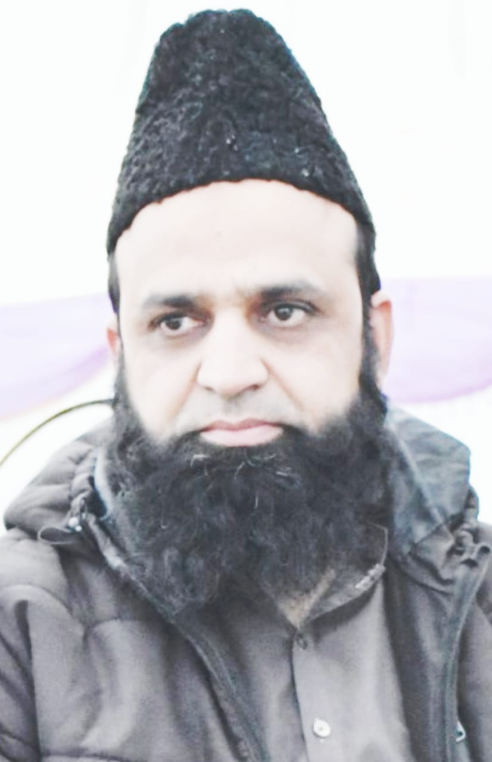
DR MUHAMMAD KAMRAN ISHFAQ
32/5 Z Block Satellite Town Jhang Pakistan +923125869091
drmkamranishfaq@gmail.com; Google Scholar: https://scholar.google.com/citations?user=oB_MEngAAAAJ&hl=en

- Dynamic and research-driven Electrical Engineering academic with over 19 years of experience, specializing in millimeter-wave antenna systems, RF front-end architectures, and cellular network infrastructure for 5G and emerging 6G technologies. Demonstrated expertise in: High-frequency antenna design for advanced communication networks, including 28 GHz phased arrays and ±220° wide-angle scanning multibeam systems. RF, beamforming techniques, and integration of the Rotman Lens and the Butler Matrix for spatial diversity enhancement.
- International collaborative projects under the supervision of Prof. Mohammad Himdi, IETR Universiti de Rennes 1, France, Prof Kunio Sakakibara, Nagoya Institute of Technology, Japan, Prof. Tharek Abd Rahman, UTM Malaysia and Prof Y. Yamada, MJIIT-UTM Malaysia
- Robust publication record with 13+ peer-reviewed articles in top-tier journals including IEEE Access, IEEE AWPL, and IET Microwaves, Antennas & Propagation.
- Advanced proficiency in EM simulation (CST, HFSS), RF circuit design (ADS), and AI-based optimization for communication systems.
- Comprehensive experience in undergraduate and postgraduate instruction, lab establishment (Microwave, Antenna, Communication Labs), and Outcome-Based Education (OBE) implementation.
- Successfully mentored PhD and MS research students in antenna design, wireless systems, and RF signal processing.

KEY SKILLS
- High-Frequency RF Design: Expertise in RF front-end design, impedance matching, and linearization for 5G/6G cellular systems.
- mm-Wave Antennas & Beamforming: Design of phased arrays and multibeam antennas at 28 GHz+, with hybrid beamforming and MIMO techniques.
- EM & RF Simulation: Proficient in CST, HFSS, ADS, and MATLAB for antenna/RF circuit modeling and system-level analysis.
- Measurement & Testing: Skilled in VNA, spectrum analysis, and anechoic chamber testing for antenna/RF validation.
- Collaborative R&D: International research collaborations (IETR France, Nagoya Tech Japan, UTM Malaysia) and multidisciplinary project leadership.
- Publications & Supervision: 13+ journal publications; experienced in postgraduate supervision and research mentoring.

W o r k E x p e r i e n c e
ASSISTANT PROFESSOR | DEPARTMENT of Electrical Engineering
Govt. College University FAISALABAD. 2- 2011– Present

Research & Innovation:

- Pioneered wide-angle scanning multibeam antenna (±220° coverage) for vehicular communications (IEEE AWPL, 2021).
- Spearheaded research on Phased arrays using multibeam antennas, contributing to advancements in 5G/6G technology and vehicular communication.
- Designed and developed a 56-element mm-wave antenna system with Rotman Lens beamforming for next-gen communication networks.
- Published 13+ journal articles on 5G/6G, MIMO systems, and terahertz communications.
.
- Academic Leadership:
- Head of Electrical Engineering Technology Department (2019–2020): Developed comprehensive Electrical Engineering Technology course curricula.
- OBE Coordinator (2020–2022): Led the Outcome-Based Education (OBE) initiative as Coordinator at DQEC ('20-'22)
- Developed labs: Established Microwave & Antenna Lab and FYP Lab with industry-grade equipment.
- Teaching & Mentorship:
- Supervised 3 PhD candidates and 50+ undergraduate projects in antenna design, IoT, and smart grids.
- Taught 9+ core courses (UG/PG) with a focus on applied learning and research methodology

Incharge | Dept of Electrical Engg. Tech
Govt College Univ. Faisalabad, PAKISTAN. 09- 2019 to 10- 2020

Lecturer | Department of Electrical Engg.
Govt College University, FAISALABAD. 11-2006 to 01-2011

- Led Department of Electrical/Telecom Engineering, GCUF (2007-2008)
- Delivered lectures on antenna design, RF systems, and wireless communication.
- Managed the Department of Electrical/Telecom Engineering, overseeing lab operations and administrative tasks.
- .
Lecturer | Dept of B-Tech Electronics
Govt College of Tech. Faisalabad. 3-2006 TO 10- 2006
- Delivering Lectures

Trainee Engineer | Electrical & Instrumentation •
Shakarganj Mills Ltd Jhang. 7- 2005 to 2-2006

- Automated sugarcane mill using PLC
- Managed E&I shift operations
- Led 24 MW powerhouse build

E d u c a t i o n

PhD (Electrical Engineering)
Universiti Teknologi Malaysia, Malaysia | 2014 – 2019

Thesis: Design and Development of Multibeam Antennas for the 5th Generation of Wireless Communications

MSc (Electrical Engineering)
University of Engg. & Tech. Lahore, Pakistan | 2006 – 2011
Thesis: An Ultra-Wideband Planar Inverted F Antenna

Bachelor in Electrical Engineering •
University of Engg. & Tech. Lahore, Pakistan | 2001 – 2005
FYP: Design and Implementation of 2.4 GHz Transmitter and Receiver for LOS Microwave Link

J o u r n a l P u b l i c a t i o n s
- SA. Babale, Muhammad K. Ishfaq, “Compact Multibeam Array with Miniaturized Butler Matrix for 5G Applications,” Computers, Materials and Continua, 72(1), 925–937, 2022.
- Raza, A., Ijaz, U., Muhammad K. Ishfaq, “Intelligent reflecting surface assisted terahertz communication towards B5G and 6G: State of the art”. Microwave and Optical Technology Letters, 64(5), 858–866. (2022).
- Muhammad K. Ishfaq, et al., “Compact Wide-Angle Scanning Multibeam Antenna Array for V2X Communications,” IEEE Antennas and Wireless Propagation Letters, vol. 20, no. 11, pp. 2141-2145, Nov. 2021,
- H. T. Chattha, Muhammad K. Ishfaq, et al., “Compact Multiport MIMO Antenna System for 5G IoT and Cellular Handheld Applications”, IEEE Antennas and Wireless Propagation Letters, vol. 1225, no. c, pp. 1–1, 2021.
- A. Raza, W. Lin, Muhammad K. Ishfaq, “A Wideband Reflector-Backed Antenna for Applications in GPR,” International Journal of Antennas and Propagation, vol. 2021, pp. 1–10, Nov. 2021,
- M. Younas, Muhammad Jawawi, Dayang Norhayati Abang Shah, Muhammad Arif Mustafa, Ahmad, Awais, Muhammad, Muhammad K. Ishfaq, “Elicitation of Nonfunctional Requirements in Agile Development Using Cloud Computing Environment,” IEEE Access, vol. 8, pp. 209153–209162, 2020.
- Muhammad K. Ishfaq, T. A. B. D. Rahman, M. Himdi, Y. Saleem, B. A. Khawaja, and F. Masud, “Compact Four-Element Phased Antenna Array for 5G Applications,” IEEE Access, vol. 7, pp. 161103–161111, 2019.
- Abubakar Sharif, Jun Ouyang, Feng Yang, Rui Long and Muhammad K. Ishfaq, "Tunable Platform Tolerant Antenna Design for RFID and IoT Applications using Characteristic Mode Analysis”, Wireless Communications and Mobile Computing, 2018.
- F. Masud, A. H. Abdullah, G. A. Salaam, and Muhammad K. Ishfaq, “Emergency Traffic MAC Protocols in Wireless Body Area Networks", Ad Hoc & Sensor Wireless Networks, 2018, 41, 83–113.
- Muhammad K. Ishfaq, T. Abd Rahman, “Multiband Split-Ring Resonator Based Planar Inverted- F Antenna for 5G Applications,” International Journal of Antennas and Propagation, Vol. 2017, no.1, pp. 1–7, 2017.
- H. T. Chattha, Muhammad K. Ishfaq, “Band-Notched Ultra-wide Band Planar Inverted-F Antenna,” International Journal of Antennas and Propagation, vol. 2012, Article ID 513829, six pages, 2012
- H. T. Chattha, Y. Huang, Muhammad K. Ishfaq, “A Comprehensive Parametric Study of Planar
Inverted-F Antenna,” Wireless Engineering and Technology, vol. 03, no. 01, pp. 1–11, 2012
- H. T. Chattha, Yi Huang, Muhammad K. Ishfaq, “Bandwidth Enhancement Techniques for Planar Inverted-F Antenna”, IET Microwaves, Antennas & Propagation, vol. 5 issue 15, 2011, pp 1872-1879.

C o n f e r e n c e P u b l i c a t i o n s
- Y. Yamada, M. C.Q Kamelia, I, I, Intan, T.A Latef, A. Farizah, Muhammad K. Ishfaq, T. A. Rahman, “Base Station Antennas for the 5G Mobile System,” IEEE Int. RF Microw. Conf. (RFM 2018), pp. 8–11, 2018.
- Muhammad K. Ishfaq, T. A. Rahman, Y. Yamada, and K. Sakakibara, “8×8 Phased series fed patch antenna array at 28 GHz for 5G mobile base station antennas,” 2017 IEEE-APS Topical Conference on Antennas and Propagation in Wireless Communications (APWC), 2017, vol. 2017–Jan, pp. 160–162.
- Muhammad K. Ishfaq, T. A. Rehman, Y. Yamada, and K. Sakakibara, “A 28 GHz Series Fed Patch Array for 5G Applications,” MJWRT 2017, 2017 IEICE Malaysia-Japan Work. Radio Technol., pp. 26–27,1- 2017.
- Muhammad K. Ishfaq, “A Novel Linear PIFA Array Antenna for Millimeter-Wave 5G Next Generation Wireless Communication System”, IICIST 2015 (1st ICRIL-International Conference on Innovation in Science and Technology), UTM KL, held on 20,4, 2015, pp-668-672
- H. T. Chattha, Muhammad K. Ishfaq, “An UWB planar inverted-F antenna for wireless applications,” in 2012 IEEE International Workshop on Antenna Technology (iWAT), Mar. 2012, pp. 128–131

R e s e a r c h F u n d i n g
- Co-PI, IUM-funded project (2019–2020): “Antenna System Solutions for Smartphones and Base Stations for 5G” – Grant value SAR 500,000.

F i n a l Y e a r P r o j e c t s (F Y P)
The following Under Graduate Projects have been Completed.
- MPPT-based Solar Charge Regulator
- X-band Transmitter and Receiver Design
- A wideband Planar Inverted F Antenna
- Solar Wheet-Cutter Machine
- Wi-Fi Controlled Solar Streetlight
- Solar Inverter Design for On-grid Applications
- Solar Inverter Design for Off-Grid 24V PV Applications with Battery Storage
- More than 40

P o s t G r a d u a t e S u p e r v i s i o n
Currently supervising four (4) PhD students.

- “Design and Development of Short-Term Load forecasting Techniques using AI for Electrical Power Systems.”
- “Design and Development of Compact Multiband and Wideband MIMO Antennas for Next Generation of Wireless Communications”
- “Design of Implantable Antennas and Non-invasive Sensors for Biomedical Applications”
- “Development of RTV-SiR Composite Coatings to Enhance Hydrophobicity and Pollution Resistance of Ceramic Insulators in High Voltage Systems”
Four (4) MS Theses finished

- Multiband Antenna for 5G Wearable Applications
- Design of MIMO Antenna for UWB Applications
- Energy Loss Reduction for High Tension Feeders Using Advanced Distribution System Planning Techniques
- An Extended UWB MIMO Antenna for Biomedical Microwave Imaging

v o l u n t e e r P r o f e s s i o n a l A c t i v i t i e s
- Lead as President, Wireless Communication Centre Student Society, Universiti Teknologi Malaysia, 2015
- Advisory Board Member, Annual IEEE-GC University Faisalabad TechFair 2008-2014
- Secretary, Electronics Club, UET Lahore, Pakistan 2003,

P r o f e s s i o n a l M e m b e r s h i p s
- Pakistan Engineering Council: PEC Registration No. ELECT/21113

T r a i n i n g s/ c e r t i f i c a t e s
- GSM, BSS (BSc 6000 and BTS 3012) hands-on Workshop by HUAWEI Technologies China at HUIET Lahore (a joint venture of HUAWEI Technologies and UET Lahore) 2011
- Trained on LabVIEW 8.0 Research Instrument and Measurement Systems (RIMS), 2008

R e s o u r c e P e r s o n
- 5th Generation of Wireless Communications, RIPHAH University Faisalabad Jan 2020
- One Day Workshop “Ansys HFSS Antenna Design” Universiti Teknologi Malaysia Mar 2015
- ‘Antenna System Solutions for Smartphones and Base Stations for 5G Wireless Communication’, IUM, 2019-2020. (Developed phased arrays for Smartphones and Base Stations for 5G)
- 5G and Beyond Wireless Communications, Govt. College University Faisalabad, Dec 2022

W o r k s h o p s / A c t i v i t i e s
- Organized 1st National Electronic Exhibition at UET Lahore, November 2003
- Organized 1st IEEE TechFair at GC University Faisalabad 2008
- CST Microwave Studio, One Day Workshop for Antenna Design, Wireless Communication Centre, March 2015
- Keysight ADS One Day training workshop for Microwave Designs by Keysight International at Wireless Communication Centre, UTM Malaysia, March 2015
- Lyx (A Professional Research Documents Editing Software) One Day Workshop at UTM Malaysia, 2014

R e f e r e n c e s
- Prof. Mohammad Himdi
Professor, Institut d'Electronique et Télécommunications de Rennes,
University of Rennes, France
Email: Mohamed.himdi@univ-rennes1.fr
Ph#: +33673605936

- Dr Inam Abbasi
Senior Lecturer, School of Electrical Technology,
Universiti Teknikal Melaka (UTeM), Malaysia
Email: inamabbasi@utem.edu.my
Phone: +60-11-16837317

- Dr Yasir Saleem
Associate Professor
University of Engineering and Technology (UET) Lahore
Email: yasir@uet.edu.pk
Ph# +92-3004134716

